Sponsored by the MWGA Promotion & Outreach Committee
Application Deadline: June 1, 2023

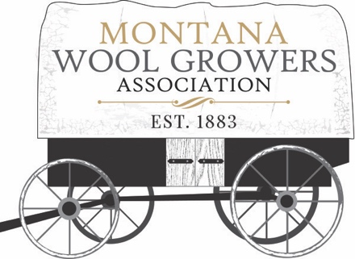

One $1000 scholarship and one $500 scholarship will be awarded to two students continuing their secondary education in a field benefiting agriculture. Students must have graduated from a Montana high school and be beginning at least their second year in college. Applicants are not restricted to attending an in state school. The school may be a university, 2-year or 4-year college, vo-tech, or any other educational facility of higher learning beyond high school.

A complete application must include:
- This Completed Application Form (use more paper if needed)
- A Letter of Recommendation
- Official transcript of grades received for completed coursework

Submission Instructions:

Send completed application with transcript and letter of recommendation by email to: MWGA Executive Secretary, Stefanie Leach at: stefanie@mtsheep.org

Please put “MWGA Scholarship 2023” in the subject line.

Applicant Name:
Date of Birth:
Address:
Phone:
Email Address:
Grade Point Average:
Name of College:
Anticipated Graduation Date:
Choice of Major:
Extra-Curricular Activities:

Offices or Positions Held:

Honors or Awards received:

Describe any agriculture related or leadership programs you have been involved in during high school and college. Through these experiences, how were you prepared to contribute to the ag industry?

Explain how you plan to use your college degree to help serve the agriculture industry?

Please write any further comments that might be relevant in helping the scholarship committee evaluate this application:

I understand that if I receive this scholarship and discontinue my education with-in the semester of receiving these funds, all money must be returned to the Montana Wool Growers Association.

__________________________________________________________________
Applicant’s Signature and Date

